Table des matières

I. Introduction 2

I.A. Purpose 2

I.A.1. Data4Help 2

I.A.2. AutomatedSOS 3

I.B. Hypothesis 3

I.B.1. Data4Help 3

I.B.2. AutomatedSOS 3

I.C. Scope 4

I.C.1. Data4Help 4

I.C.2. AutomatedSOS 4

I.D. Definitions, Acronyms and abbreviations 5

I.E. Revision history 5

I.F. Reference Documents 5

I.G. Document Structure 5

II. Data4Help : Overall description 6

II.A. Product perspective 6

I.A.1. Shared phenomena 6

I.A.2. Domain assumptions 6

I.A.3. Domain model 6

III. Data4Help : Specific requirements 6

III.A. External interfaces requirements 6

III.A.1. User interfaces 6

III.A.2. Hardware interfaces 6

III.A.3. Software interfaces 6

III.A.4. Communication interfaces 6

IV. AutomatedSOS : Overall description 6

IV.A. Product perspective 6

I.A.4. Shared phenomena 6

I.A.5. Domain assumptions 6

I.A.6. Domain model 6

V. AutomatedSOS : Specific requirements 6

V.A. External interfaces requirements 6

V.A.1. User interfaces 6

V.A.2. Hardware interfaces 6

V.A.3. Software interfaces 6

V.A.4. Communication interfaces 6

# Introduction

## Purpose

The purpose of this document is to define the requirements analysis and specification document (RASD) of the services Data4Help and AutomatedSOS offered by the company TrackMe. This document contains the requirements of the system to be developed and its application domain. It can be used as a baseline for software evaluation and for charge control.

### Data4Help

Data4Help is a software-based service allowing third parties to monitor the location and health status of individuals. Data4Help supports the registration of individuals and of third parties.

* Individuals who register to Data4Help allow the company TrackMe to acquire their data.
* Third parties who register to Data4Help can access the data acquired by TrackMe by the mean of requests. They can request to :
  + Access to the data of a specific individual by providing a unique identifier. The request is then transferred to the individual who decide to accept or refuse it.
  + Access to anonymized data of groups of individuals. The request is accepted if the number of individuals satisfying it is higher than 1000.

When a request is approved, third parties must be able to access the previously saved data and to subscribe to the request. By subscribing, third parties will receive the new data corresponding to the request as soon as they are produced. If the individual cancels his agreement or if the data cannot be anonymized anymore, the subscription is automatically cancelled.

* [G 1] : Third parties must be able to request to access to the data of specific individuals or to anonymized groups of individuals.
* [G 2] : At any time, third party should never have access to data of specific individuals without their agreement.
* [G 3] : Third parties must have the possibility to subscribe to new data if their request is accepted.

### AutomatedSOS

Automated SOS is a service build on top of Data4Help, thus AutomatedSOS must verify all the requirements of the service Data4Help. In addition, AutomatedSOS offers the possibility to monitor the health of the subscribed customers and to automatically send an ambulance to the location of the customers if their health parameter are below certain thresholds.

The goal of the service AutomatedSOS is to send an ambulance to the location of the customer with a reaction time below 5 seconds from the time the parameters are below threshold.

All the goals of Data4Help are also goals of Automated SOS

* [G 4] : An ambulance is requested to the location of the customer with a reaction time below 5 seconds from the time the parameters are below threshold

## Hypothesis

### Data4Help

To solve the ambiguity and incompleteness of the assignment, the following choices have been made:

* The data is collected by the mean of a smartwatch synchronized to a smartphone application. We made this choice because most of the smartwatches currently on the market are aimed to be linked to a smartphone through an application and we want our software to run on as many platforms as possible (design for portability)
* The subscription to a request on a group of individuals is automatically cancelled if the number of individuals whose data satisfy the request goes bellow 1000 at some point.
* The subscription to a request on a specific individual is automatically cancelled if the individual cancels his agreement.
* The user can see the data collected by the service Data4Help.
* Data4Help must respect the General Data Protection Regulation (GDPR)

### AutomatedSOS

To be completed.

## Scope

In this section, we will give a brief description of the world and of the shared phenomena. By “world” we intend the portion of the real world that is affected by the machine and by “machine” we mean the portion of system to be developed. A phenomenon shared by the world and the machine can either be controlled by the world and observed by the machine or controlled by the machine and observed by the world.

### Data4Help

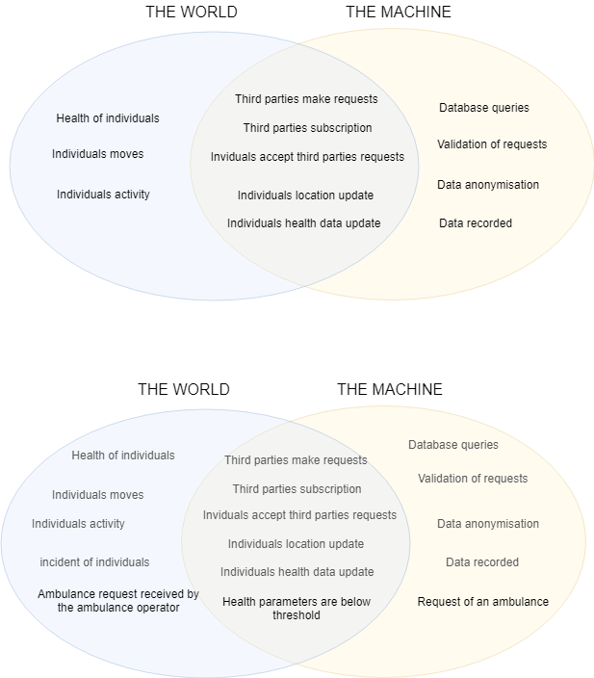

### AutomatedSOS

The world and the machine are mainly the same for the service AutomatedSOS as it is built on top of Data4Help. Indeed, AutomatedSOS must have all the functionalities of Data4Help in addition to the SOS service.



## Definitions, Acronyms and abbreviations

Third party: company or organization that need to access data of individuals

Individual: person owning a smartwatch and willing to share his data with a third party.

Smartwatch: device aimed to be worn on the wrist. A smartwatch can collect data, can be linked to a smartphone application and can support wireless technologies like Bluetooth, Wi-Fi, and GPS.

Subscription : to be completed

## Revision history

to be completed

## Reference Documents

to be completed

## Document Structure

to be completed

Data4Help

# Data4Help : Overall description

## Product perspective

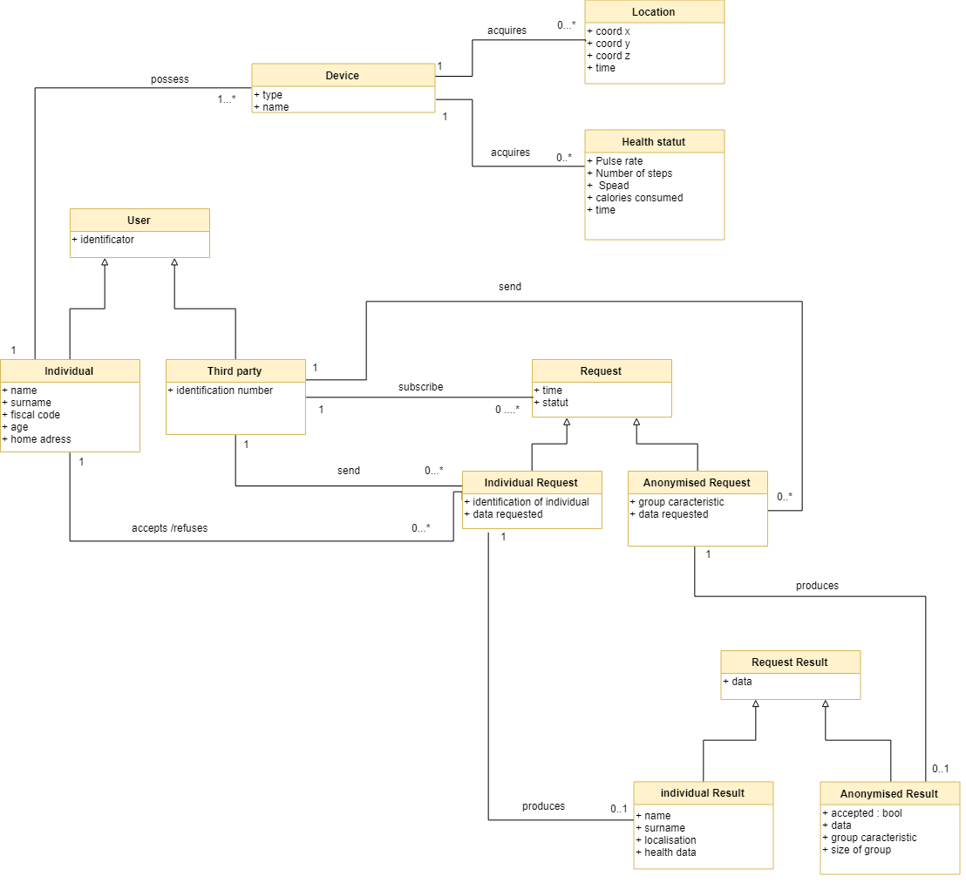

## Product functions

## Users characteristics

## Assumptions, dependencies and constraints

# Data4Help : Specific requirements

## External interfaces requirements

### User interfaces

App inventor2

### Hardware interfaces

### Software interfaces

### Communication interfaces

AutomatedSOS

# AutomatedSOS : Overall description

## Product perspective

### Shared phenomena

### Domain assumptions

### Domain model

Further details on the shared phenomena and domain model (class diagrams and statecharts)

# AutomatedSOS : Specific requirements

## External interfaces requirements

### User interfaces

### Hardware interfaces

### Software interfaces

### Communication interfaces